BIG DATA 12/04/2022

Update with Set

db.sohan.updateOne(
... {"name" : "shriman"},
... { $unset : { "dept" : ""}})
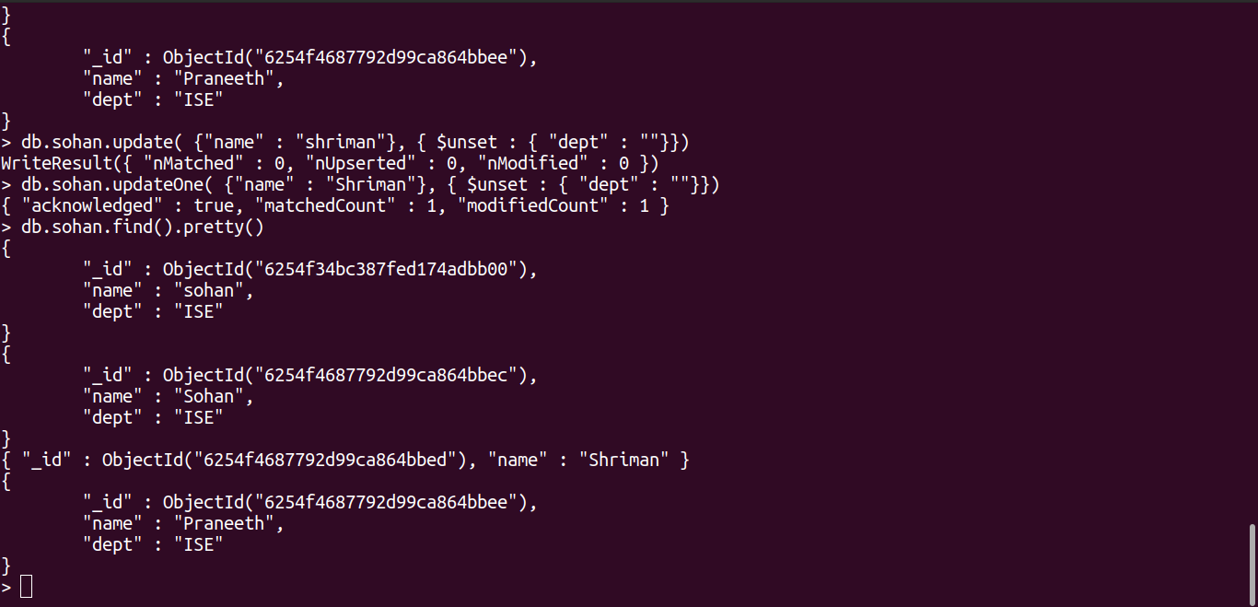

Update with UnSet

db.sohan.update( {"name" : "Sohan"}, { $unset : { "dept" : ""}})
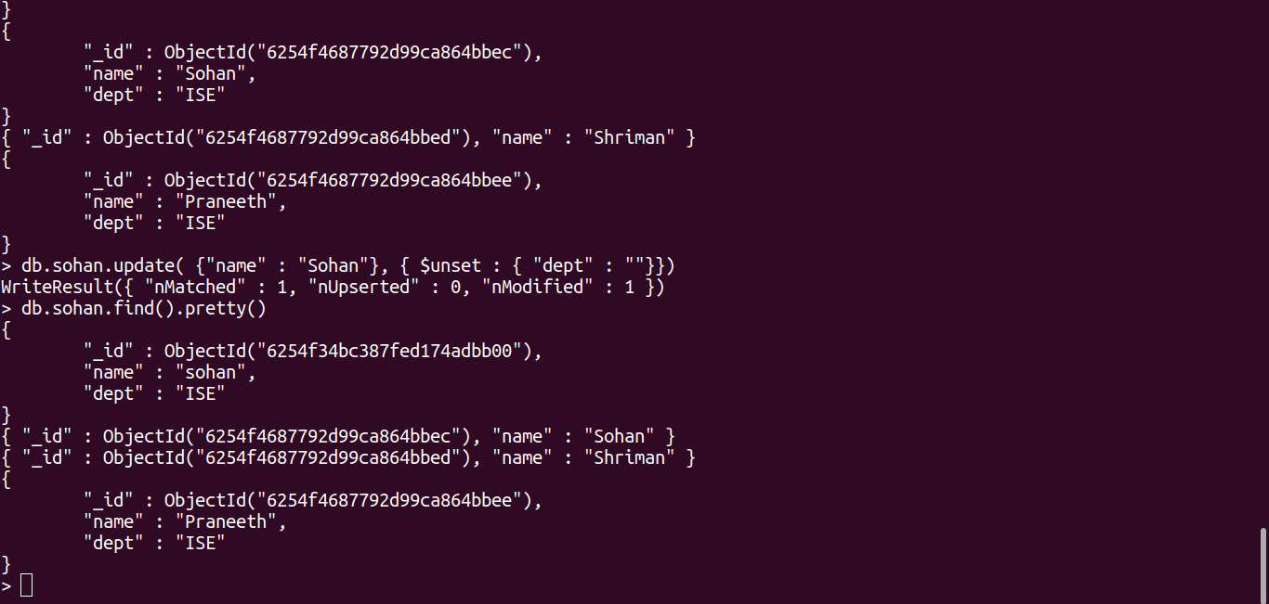

OR

db.sohan.find({$or: [{dept: "ISE"},{dept:"cse"}]}).pretty()
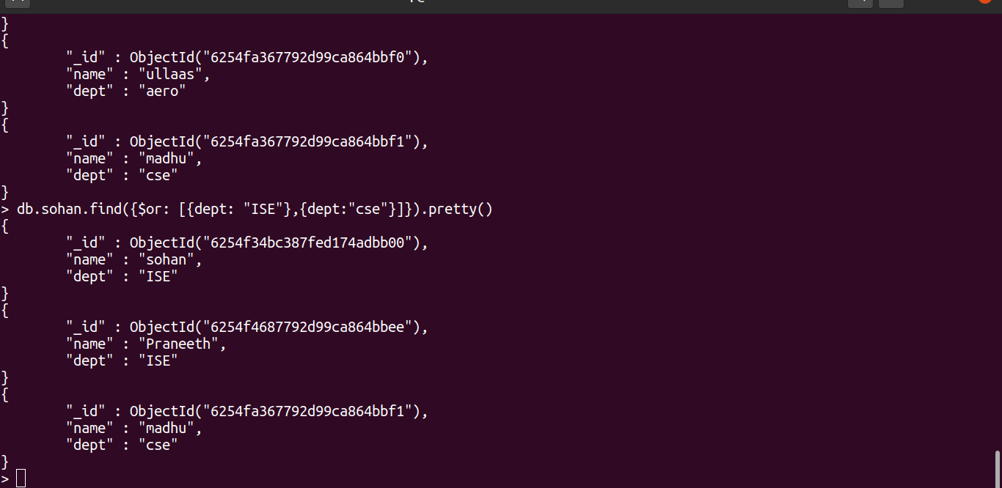

And

db.sohan.find({$and: [{dept: "ISE"},{name: "sohan"}]}).pretty()

